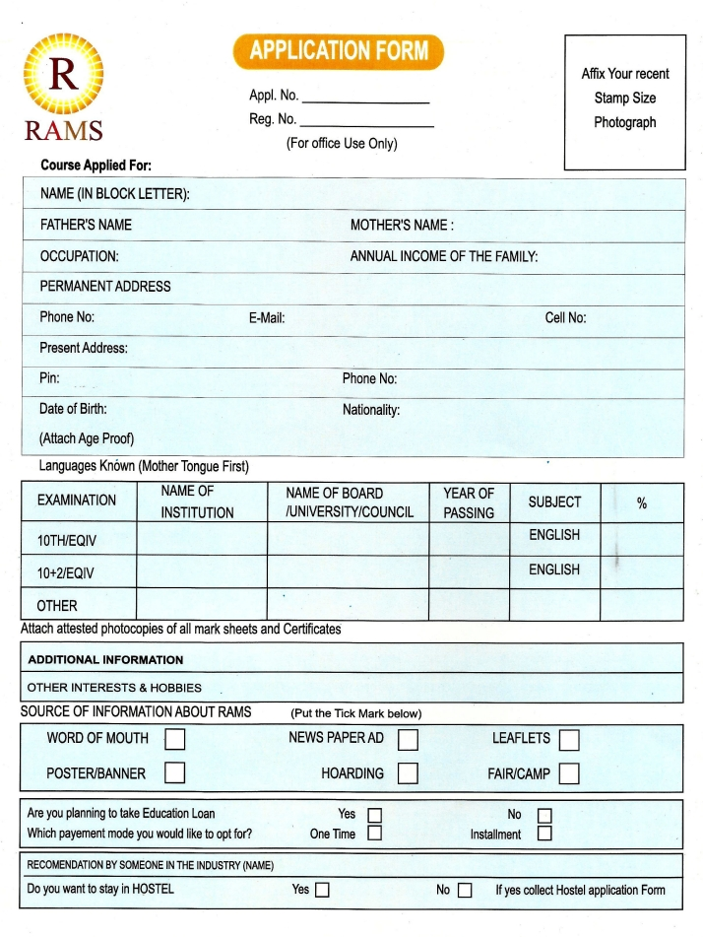N

Paste your photograph here

DEBANJAN BHOWMIK

3YrsDegree/18 monthsDiploma/1yr Diploma in Hotel Management

optional

