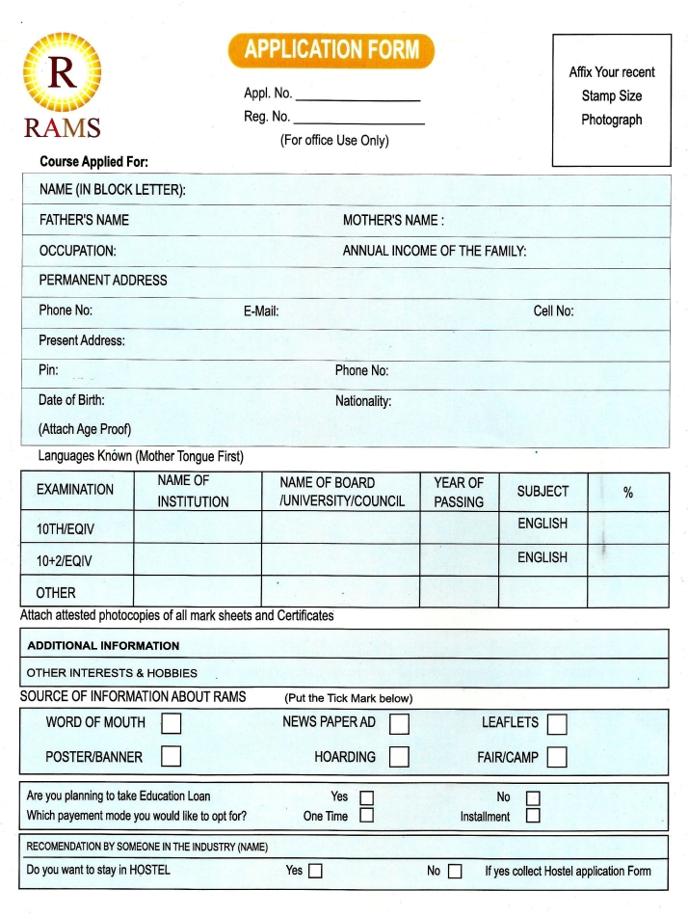
N
Paste your photograph here
DEBANJAN BHOWMIK

3YrsDegree/18 monthsDiploma/1yr Diploma in Hotel Management

optional

